Assignment-2

Create a Jenkins master, Clone the LoginWebApp project from git, compile, build. Take the war file and deploy it to another EC2 instance which is not a slave machine. Don’t start/stop the tomcat on another EC2 machine, keep it running.
1. Jenkins master and another EC2 instance where the war file needs to be deployed
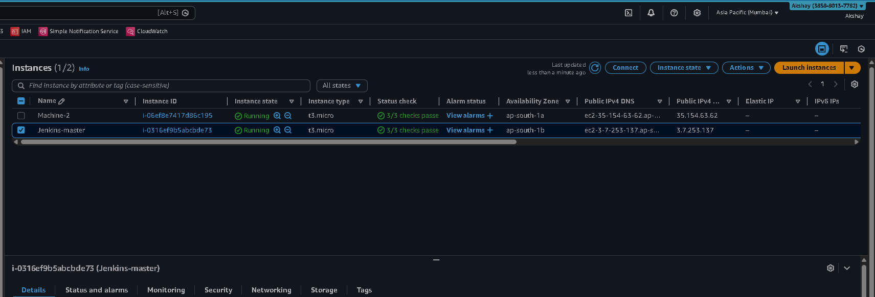

2. Jenkins job configuration
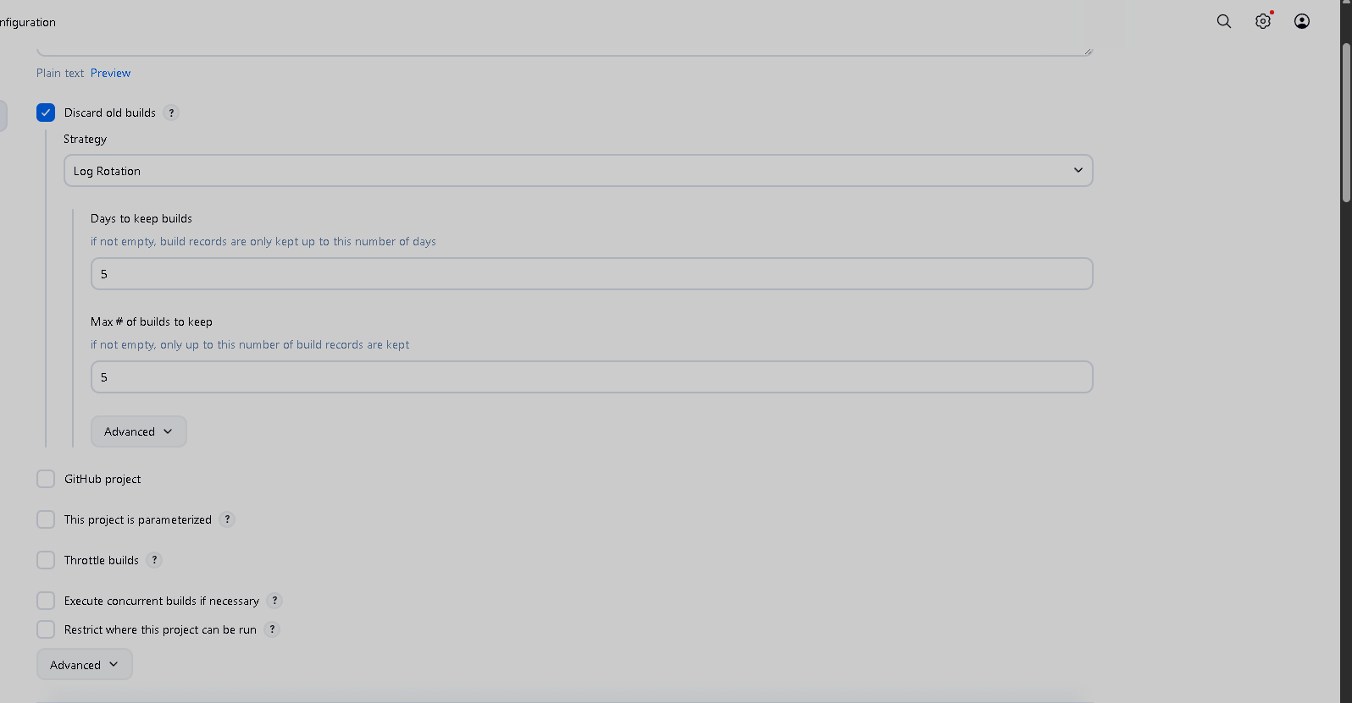
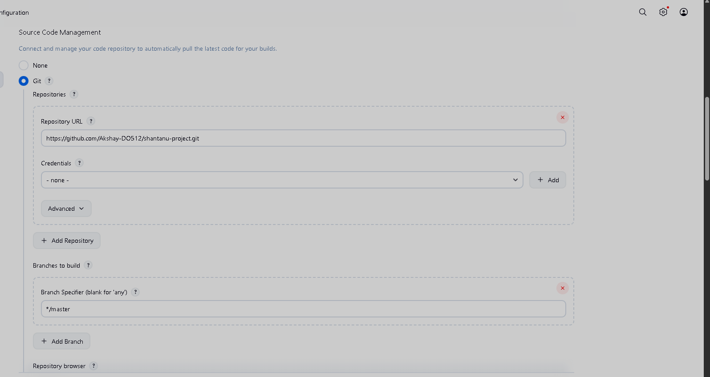
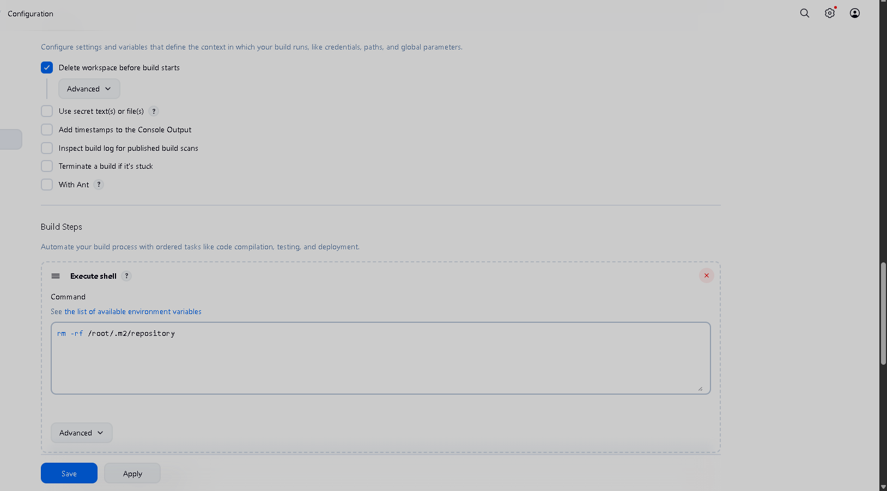
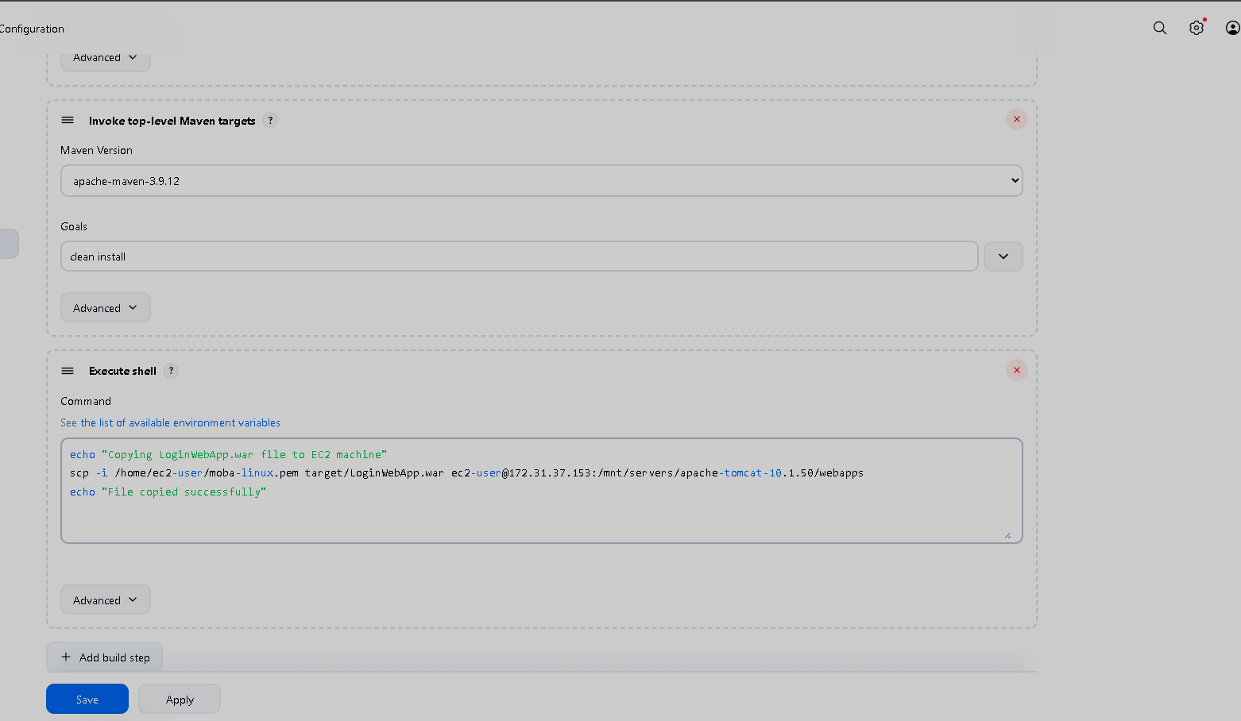

Output:
